ICDFA Ethical Hacking Internship
Lab 1: Investigate Kali Linux Documentation
Written by: Fatima Abubakar
Student ID: ICDFA/2026/FAT/1542

Challenge 1:
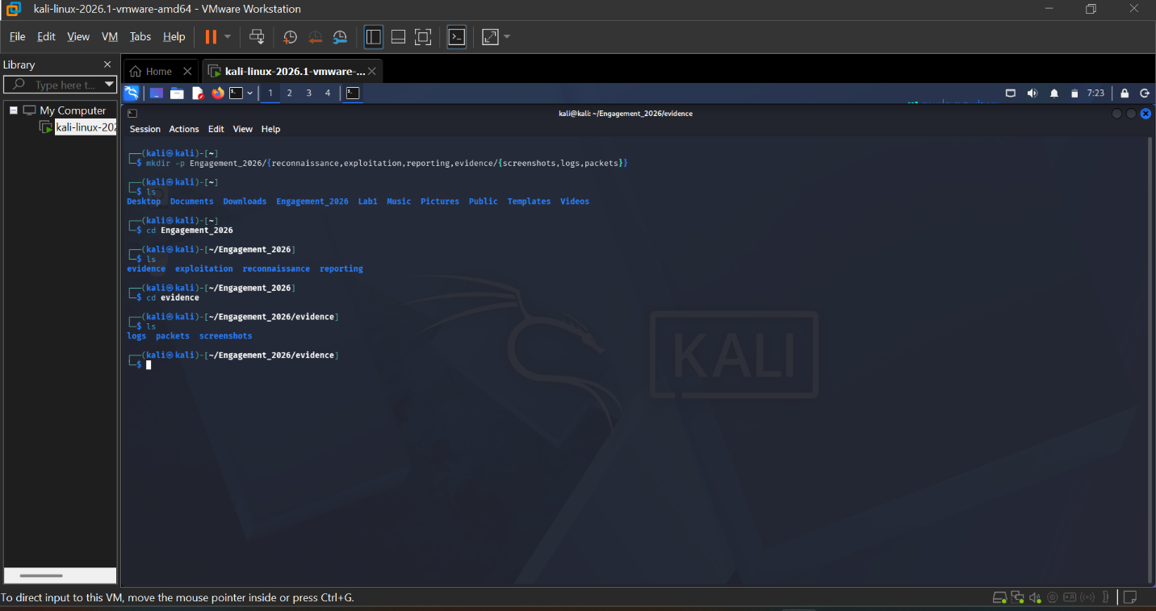
I use complex directory structure command to create directory structure for a penetration test engagement by creating a main directory called Engagement_2026 with different subdirectories reconnaissance, exploitation, reporting, evidence and evidence contains subfolders, screenshots, logs and packets respectively.

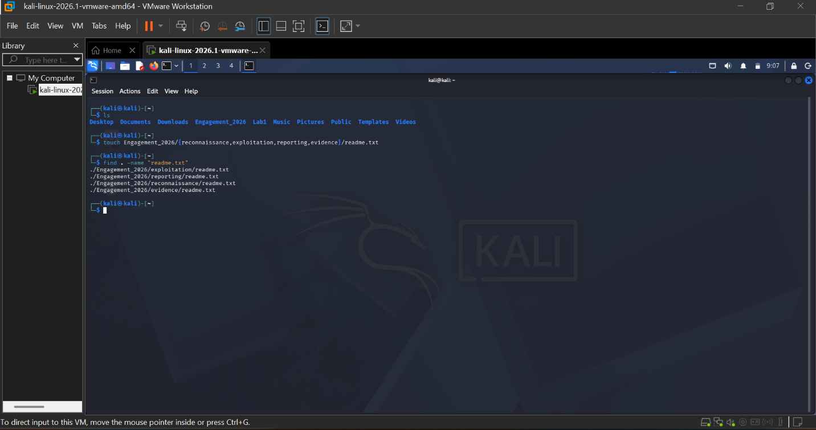

And finally, here I created a readme.txt file in each main directory by using complex directory command and I find the readme.txt file to make sure is created accordingly.

Challenge 2:
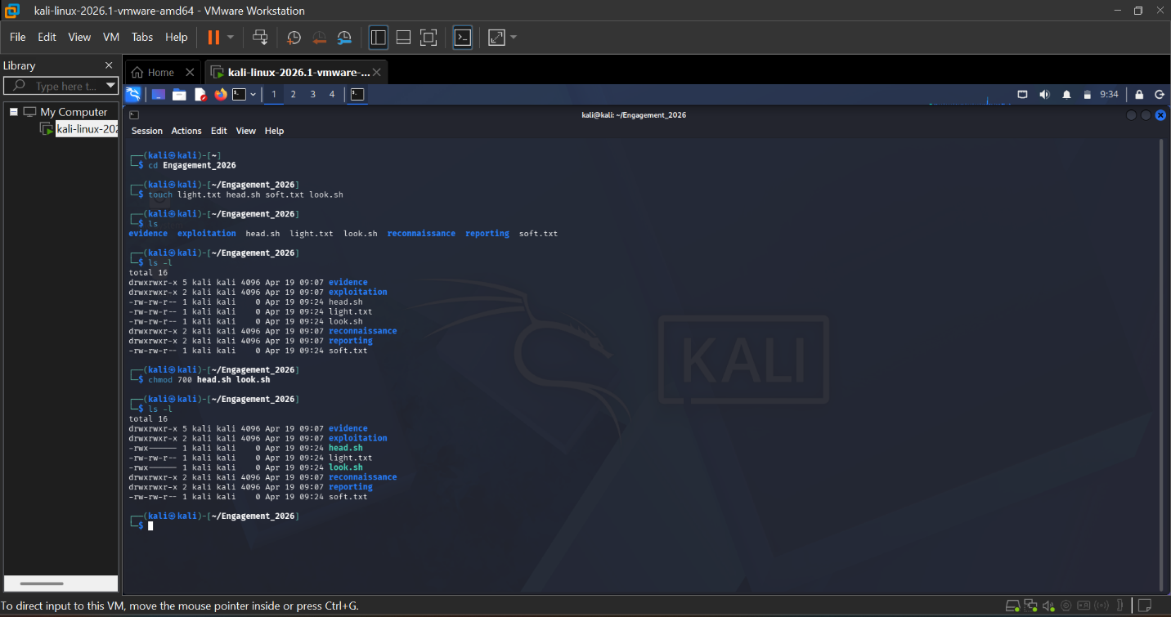

Here, I created files with .sh and .txt and I changed the permission command for all .sh files to be executable only by the owner by using chmod command. And finally, I used the ls -l command to verify the permissions changed.

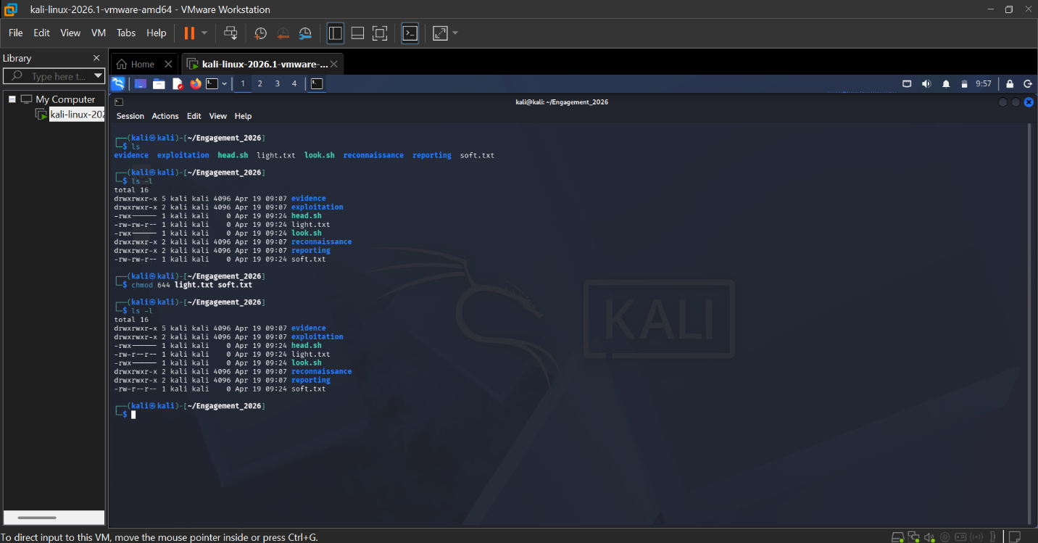

Here, I used the chmod to execute this command for all .txt files with should be readable by everyone but only writable by the owner and to verify the permissions change is used ls -l command.

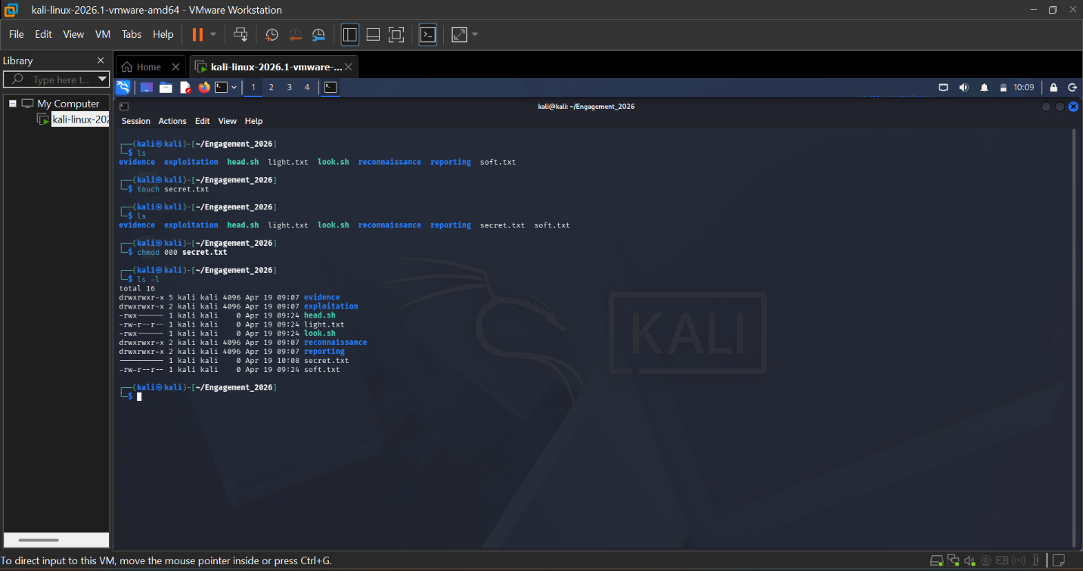

Here, I created a file secret.txt file and used chmod command to change permissions of all not to read, write and execute. And lastly, I used ls -l command to verify the changes.

Challenge 3:
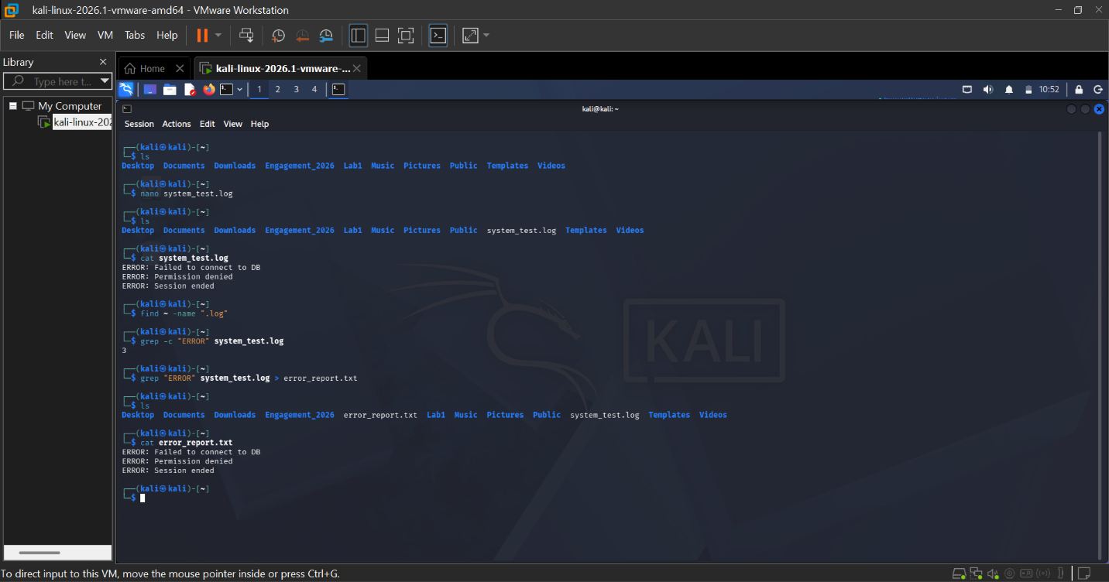
Here, I create a file called system_test.log by using nano command and parsed the ERROR Messages in the nano editor. I later, used the ls command to verify that the system_test.log file was created. I then, used cat command to view the errors. I used find ~ command to find the file .log in the home directory. Then, I used grep -c to count how many lines contains the ERROR. And lastly, I save the results to a file called error_report.txt.

Conclusion:
This lab demonstrates proficiency in Linux command-line administration for cybersecurity operations. I established a structured directory for penetration testing and enforced the Principle of Least Privilege using advanced file permissions. Here, I generated a sample log file to demonstrate the ability to parse system data for specific security events. By utilizing tools like find and grep, I successfully identified and reported critical system errors. These tasks reinforce the foundational skills necessary for effective system hardening and incident response.
All tasks were performed within Kali Linux VMware Workstation to ensure the safety and integrity of the host system, following standard ethical hacking protocols.

